Milestone 2
Nowrin Mustary
Faculty of Computing & Data Sciences, Boston University
Data Science Capstone
Dr. Joshua Von Korff
Aug 3, 2025

Problem Statement
This project explores how property pricing and behavior patterns vary across two real-world datasets: the Austin Housing dataset and the Airbnb Listings dataset. These two represent very different markets. Austin housing follows a more traditional real estate setup with geographic and physical property attributes, while Airbnb deals with short-term rentals where both listing features and host behavior come into play.
The goal is to use different modeling techniques to predict prices and find patterns through clustering. The insights from this analysis could be valuable for homeowners, renters, and investors. They can help guide pricing strategies, shape investment decisions, and assess risk in both long-term and short-term rental markets.
Week 8: K-Nearest Neighbors (KNN) Modeling
KNN was used for both regression and classification. To evaluate classification, I created a binary target based on whether a listing’s price was above the median. This made it easier to look at price segments.
For the Austin dataset, using Manhattan distance gave the best results. It achieved a classification accuracy of 85.4 percent and an F1-score of 0.85. This makes sense since Manhattan distance works well in grid-like cities where properties may not be spaced diagonally. KNN regression also performed best with Manhattan distance, reaching an R² of 0.4746. That’s not highly accurate but still captures some of the variability in the data.
Airbnb classification accuracy came in slightly lower at 81.8 percent, and F1-scores were reduced due to class imbalance. However, the regression model was more accurate here, with an R² of 0.6353. This likely comes from Airbnb's feature-rich dataset. Variables like host reviews, listing availability, and booking frequency added more depth, which helped the model even though Airbnb prices are noisy and often have outliers.
Week 9: Gradient Boosting Regression
I then tried Gradient Boosting to improve performance and limit overfitting. For Austin, I used grid search to test 72 combinations of parameters with 3-fold cross-validation. The best model had 200 estimators, a learning rate of 0.05, and a maximum tree depth of 5. This resulted in a test RMSE of around 314,000 dollars and an R² of 0.5833. That was a clear improvement over KNN and previous linear models. The slower learning rate helped control complexity while still allowing the model to learn gradually.
Airbnb required more tuning. I tested 162 different combinations and found the best results with 350 estimators, a learning rate of 0.1, and a max depth of 4. This model had an RMSE of 262.08 and an R² of 0.7201. The slightly shallower trees worked well because Airbnb data is noisier and more complex. This tuning helped avoid overfitting and showed that smaller trees paired with more boosting rounds can be a better fit for that kind of data.
Week 10: K-Means Clustering
K-Means was applied to both datasets to look for natural groupings. For Austin, I scaled the numeric features and ran the elbow method. The results showed a steady decline in SSE, from 546,156 at k equals 1 to 322,426 at k equals 12. There was no sharp bend in the curve. Silhouette scores were also low across the board, with a maximum of 0.1301 at k equals 11. When I visualized k equals 3 using PCA, the clusters overlapped quite a bit. This suggests that Austin housing features do not separate easily into clear, compact groups, possibly because of limited feature diversity or a more complex structure.
Airbnb clustering performed better. The elbow curve showed a leveling-off effect after k equals 3, and silhouette scores peaked at 0.5786 for k equals 2. PCA also showed two distinct groups. These may represent budget listings versus premium listings or differences in host styles. Airbnb’s feature diversity made K-Means a better fit for this dataset. The results demonstrate how well clustering works depends heavily on the characteristics of the dataset.

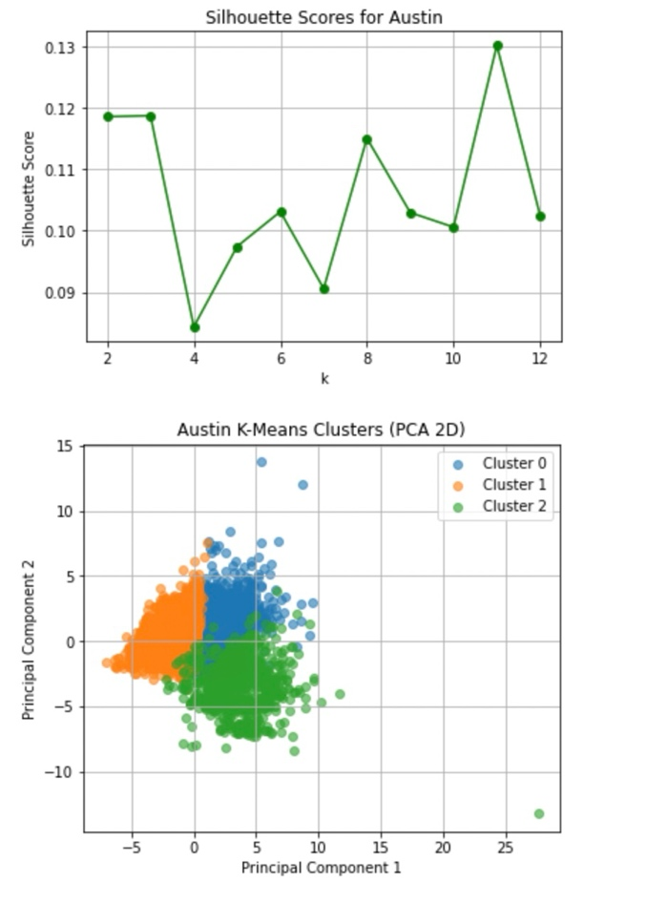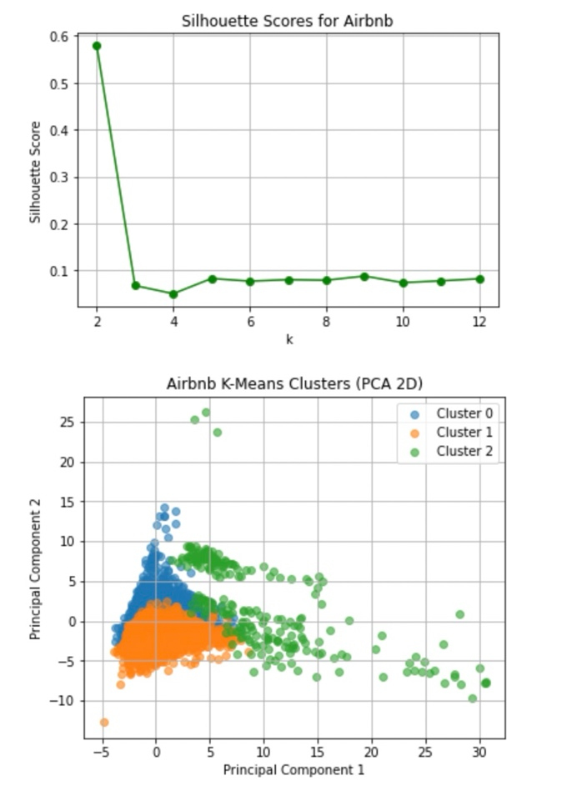
Week 11: DBSCAN and Hierarchical Agglomerative Clustering
In Week 11, I explored two clustering methods beyond K-Means: DBSCAN and Hierarchical Agglomerative Clustering (HAC). Both were applied to the Austin and Airbnb datasets to see if more flexible or hierarchical structures would uncover better groupings. For DBSCAN, I tuned the key parameter eps using k-distance plots to find a balance between identifying meaningful clusters and filtering out noise.
In the Austin dataset, DBSCAN found 7 clusters with a silhouette score of 0.6164 when eps was set to 16. When I increased eps to 17 and 18, the model produced 5 clusters and the silhouette score jumped to 0.7409. That improvement suggests DBSCAN handled Austin’s irregular patterns well. The ability to filter noise points also seemed to help by reducing the influence of outliers. On the other hand, HAC only managed a silhouette score of 0.3563 using 3 clusters, which points to weaker grouping performance for this dataset.
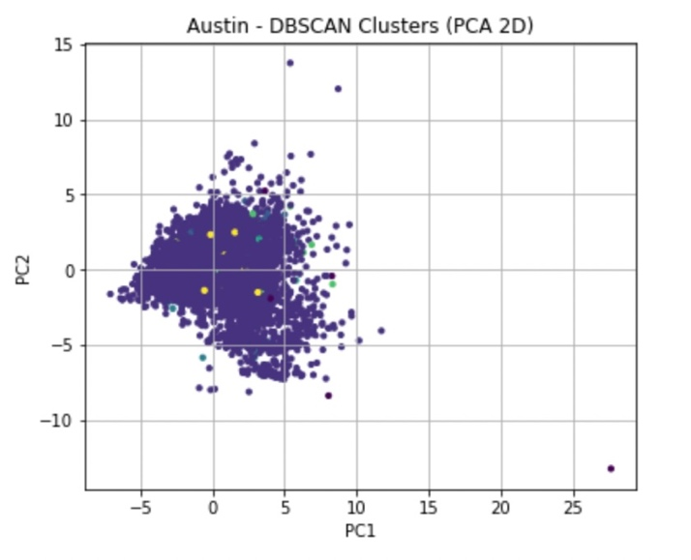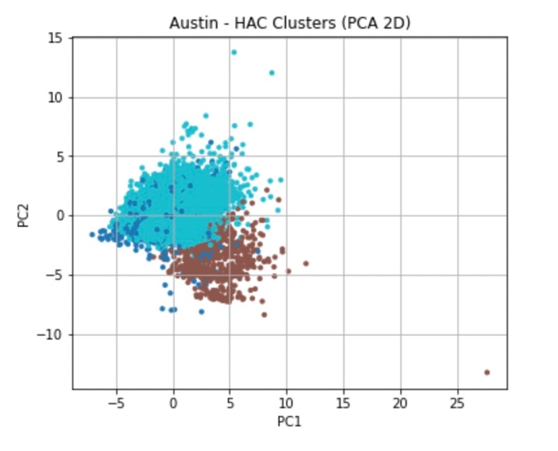
Results were different for Airbnb. At eps = 12, DBSCAN created 7 clusters with a silhouette score of 0.5196. HAC outperformed it here, scoring 0.6063 with just 3 clusters. This implies the Airbnb data may have a stronger hierarchical structure, something HAC is better designed to capture compared to DBSCAN’s density-based approach. 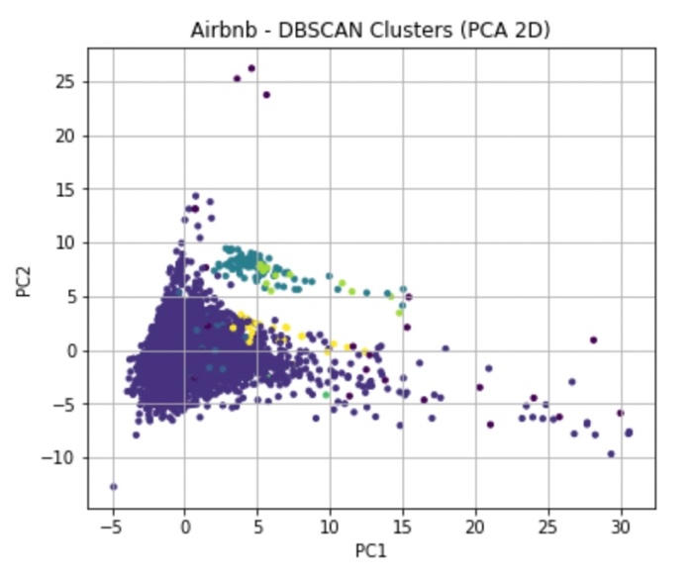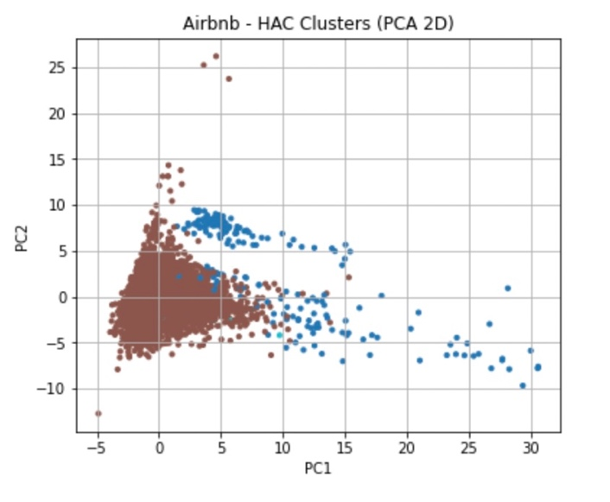
Tuning eps showed DBSCAN’s sensitivity to this parameter, affecting cluster count, noise points, and silhouette scores. These results emphasize the importance of careful eps selection to balance cluster resolution and noise.
Tuning eps showed how sensitive DBSCAN is to that parameter. It affects how many clusters get formed, how much noise is filtered, and what the silhouette scores look like. Getting the value right is important for meaningful results.
Overall, DBSCAN worked better for Austin because of its flexibility with cluster shapes and noise handling. HAC did a better job with Airbnb, possibly because the features there lend themselves to more layered, nested relationships. These differences show how clustering results depend heavily on choosing a method that fits the structure of the dataset.
Overfitting and Model Robustness
Overfitting was something I paid close attention to during Weeks 8 through 11. KNN, being a non-parametric model, helped avoid overfitting by relying on local data neighborhoods. However, its performance still depended on the right choice of k and the distance metric. I tuned both to find a balance between underfitting and overfitting.
In Gradient Boosting, I managed overfitting by adjusting hyperparameters like the learning rate, tree depth, and number of estimators. Using slower learning rates and smaller trees turned out to be helpful for generalization. These changes led to better results on the test sets without introducing too much variance.
With clustering, overfitting can happen in a different way. Sometimes, clusters form around noise or outliers that don’t represent real structure. This seemed to be the case with Austin’s K-Means results, where silhouette scores were low. DBSCAN helped reduce that problem by labeling outliers as noise, which improved overall cluster quality. I used silhouette scores consistently to measure whether the clusters made sense or were too scattered.
Hyperparameter Tuning and Metrics
I approached tuning carefully and treated it differently for each dataset. In Gradient Boosting, I used grid search and tested hundreds of hyperparameter combinations. I also used 3-fold cross-validation to prevent overfitting and ensure the results would hold up on new data. Key parameters like learning rate, number of trees, and depth had a direct impact on how well the models could fit the data without memorizing it.
For clustering, I relied mostly on silhouette scores to guide the choice of k in K-Means and eps in DBSCAN. The k-distance plots were especially helpful for DBSCAN, letting me see where natural breaks occurred in the distance values between points. These visuals helped tune the balance between cluster size and noise handling.
For the supervised models, I used RMSE and R² for regression accuracy, since those reflect how well continuous price values were predicted. For classification, I looked at both accuracy and F1-score, especially because of class imbalance in the Airbnb dataset.
Expected and Unexpected Findings
Some results lined up with what I expected. For example, Airbnb’s wide range of features and host behaviors gave better regression performance and clearer clusters. KNN and Gradient Boosting models also did better on this dataset, likely because of the richer inputs.
One thing that surprised me was how poorly Austin’s housing data clustered under K-Means. Even though the properties vary in price and size, the clustering results were weak. This made it clear that K-Means couldn’t capture the true structure in Austin’s data. Once I tried DBSCAN, the clusters became much stronger, which suggests that housing markets may have more irregular, non-spherical patterns shaped by location and neighborhood effects.
The low silhouette scores from some models served as a reminder that clustering is very context dependent. Sometimes, poor separation is just part of the dataset’s nature and not something that can be forced.
Conclusion
Looking across all the modeling and clustering work from Weeks 8 through 11, it’s clear that different datasets need different approaches. In KNN, the choice of distance metric made a big difference and showed how data geometry matters. Gradient Boosting gave strong results when paired with careful tuning of learning rate, depth, and estimators.
Clustering revealed that feature complexity plays a big role in how well groups can be identified. K-Means worked reasonably well on Airbnb but failed to separate Austin’s housing data. DBSCAN was better suited for Austin because of its flexibility with shapes and outlier filtering, while HAC gave clearer clusters in Airbnb due to the nested structure of that data.
In every case, avoiding overfitting and using the right metrics to guide decisions helped produce results that were both reliable and interpretable. The project shows how important it is to match models and techniques to the data itself, not just follow a single method for every problem. These lessons can be applied in real estate analytics, helping guide decisions with more confidence and precision.

References
Scikit-learn developers. (n.d.). K-nearest neighbors. Scikit-learn. https://scikit-learn.org/stable/modules/neighbors.html
Scikit-learn developers. (n.d.). Gradient boosting. Scikit-learn. https://scikit-learn.org/stable/modules/ensemble.html#gradient-boosting
Scikit-learn developers. (n.d.). K-means clustering. Scikit-learn. https://scikit-learn.org/stable/modules/clustering.html#k-means
Scikit-learn developers. (n.d.). DBSCAN clustering. Scikit-learn. https://scikit-learn.org/stable/modules/clustering.html#dbscan
Brownlee, J. (2021, July 23). A gentle introduction to k-nearest neighbors algorithm (KNN) for machine learning. Machine Learning Mastery. https://machinelearningmastery.com/tutorial-to-implement-k-nearest-neighbors-in-python/

